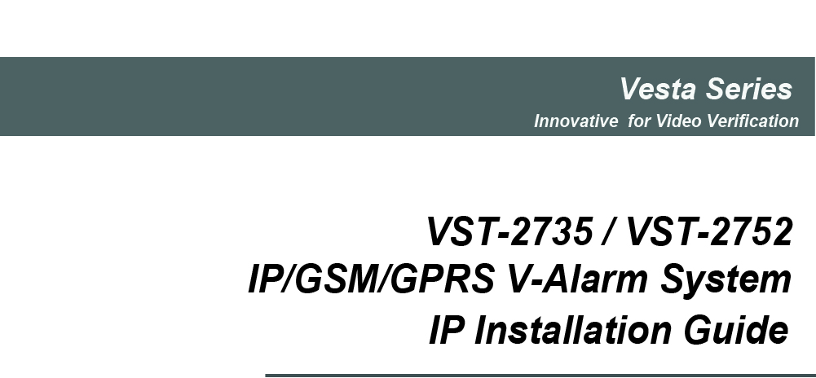

Aug-1-2013

Table of Contents

1. Introduction 1
2. Application Overview 1
2.1. Identifying the parts: 1
2.2. The Power Supply: 3
2.3. System Requirements: 3
3. Getting Started 4
3.1. Hardware Installation 4
3.2. Software Installation 4
4. Connecting to Webpage 7
5. SYSTEM SETTINGS 9
5.1. User 9
5.2. Report 11
5.3. Panel 14
5.4. Area 14
5.5. Network 19
5.6. GSM 21
5.7. Upload 23
6. Device Management 24
6.1. Learning 24
6.2. Add Device 27
6.3. Walk Test 28
6.4. Edit Device 29
6.5. Delete Device 32
6.6. Request Media 32
6.7. Power Switch Control 33
6.8. Siren Learning/Control 33
7. Captured Events 34
8. History Records 34
8.1. History 36
8.2. Reported Event 37
9. Panel Control 38
10. Home Automation 39
11. Firmware 41
12. Event Code 42

1. Introduction
This manual covers the installation, programming, and control of IP based VST-2735 and VST-2752 control panels. Both VST-2735 and VST-2752 supports full range IP reporting capability with webpage for setting configuration and system control, VST-2752 also has the extra function of reporting through GSM and/or GPRS.
The advanced IP Security System with fully integrated TCP/IP technology and Ethernet connectivity is able to take full advantage of new advances in IP Home Security and Home Automation and multi-path signalling.
Remote control of the panel is achieved by registering the panel in our Home Portal Server. With Home Portal Server, you can connect to your panel anytime, anywhere in the world through internet connection either with a computer or a smartphone using our Vesta Home application. Please refer to our Home Portal User Guide for detail about registering and using Home Portal Server.

2. Application Overview
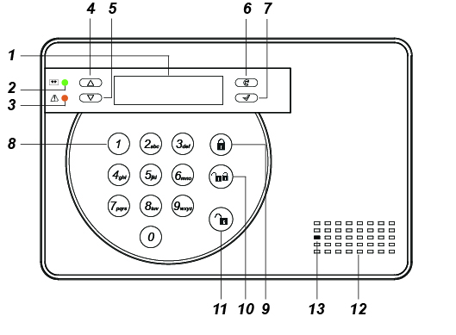
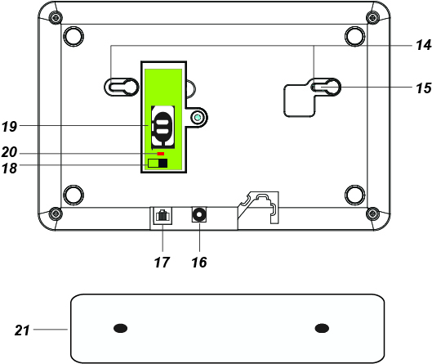

2.1. Identifying the parts:
1. Backlit LCD Display
2. Green LED
ON: AC Power is on.
OFF: AC Power failure.
3. Yellow LED
ON: Fault Indicator; the Yellow LED will light up when any fault situation is detected and turn off when all fault conditions are restored.
4.  Key
- Use this key to move the cursor and scroll the display upwards
5.  Key
- Use this key to move the cursor and scroll the display downwards.
6. Key

— Use this key for deleting a digit, canceling the selection, aborting the current screen and returning to the previous screen etc.
7. OK Key
- To confirm the keyed-in data or confirm the selection.
8. Numeric Keys
9. Away Arm Key
— Use this key to Away Arm the system.
10. Home Arm Key
— Use this key to Home Arm the system.
11. Disarm Key
— Use this key to Disarm the system.
12. Buzzer
13. Microphone
14. Mounting Holes & Tamper
15. Tamper Switch
16. DC Jack
- For connecting the DC 12V 1A power adaptor.
17. Ethernet Port
18. Battery Switch
19. GSM/GPRS SIM Card Base (VST-2752 Only)
20. GSM/GPRS LED
- On for 5 seconds when power is supplied.
- Flash Slowly: GSM normal.
- Flash Quickly: GSM failure.
21. Wall Mounting Bracket
- For mounting the Control Panel on the wall.

2.2. The Power Supply:
An AC power adapter is required to connect to a wall outlet. Be sure only to use an adapter with the appropriate AC voltage rating to prevent component damage. DC 12V 1A switching power output adaptor is generally used to power the Control Panel for standard version.

Rechargeable Battery
- In addition to the adapter, there is a rechargeable battery inside the Control Panel, which serves as a back up in case of a power failure.
- During normal operation, the AC power adapter is used to supply power to the Control Panel and at the same time recharge the battery. It takes approximately 72 hours to fully charge the battery.
<Note>
    - If the AC power is missing and the battery is near exhaustion, a low battery message will be displayed and the internal siren will be disabled to conserve power.

2.3. System Requirements:
The system requires a TCP/IP network environment for the Control Panel to be included in your network.
To install the CD Wizard, your computer must have:
  - Microsoft Windows 98, ME, NT4.0, 2000, XP, Vista, 7, or 8 operating system.
  - Microsoft Internet Explorer 5.x, or later and Mozilla Firefox 1.0 compatible.
  - CD-ROM drive
  - CPU: Intel Pentium II 266MHz or above
  - Memory: 32MB (64MB recommended)
  - VGA resolution: 800x600 or above

3. Getting Started
Read this section of the manual to learn how to set up your Control Panel and program System Settings over the Web page.

3.1. Hardware Installation
Step 1. Connect the Power Adaptor to a Wall Outlet and the other end to the Control Panel. The Control Panel will emit one short beep and Panel Status GREEN LED will turn ON.
Step 2. Connect the Ethernet cable to the Ethernet port.
Step 3. Hardware installation for the Control Panel is now complete.

3.2. Software Installation
※ THIS INSTALLATION IS ONLY REQUIRED FOR FIRST TIME USER ※
- RUNNING THE FINDER
To install the “Finder” software”
Step 1. Insert the supplied CD-ROM into your CD-ROM drive
Step 2. Find the Finder software in the CD-ROM
Step 3. Double click on the Finder to initiate the installation.
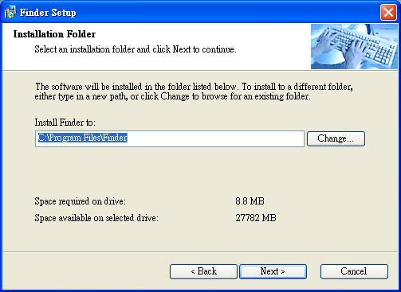
Step 5. Click “Change” to select the file folder, if no change is required; click “Next” to get ready for the installation process.
Step 6. Click “Next” to begin the Installation. Once the installation is completed, click “Finish” to confirm.
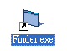
Step 7. A new icon will be displayed on your desktop.
Step 8. Double click on the “Finder.exe” to start the installation. The following screen will be displayed:
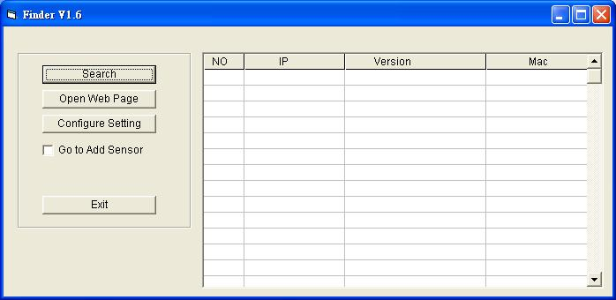
Step 9. Click on “Search”, It will start searching for recognized IP address within the Local Network Service.
Step 10. You will be able to locate the current Control Panel IP address among the list.
Displayed with MAC Address and Product version.
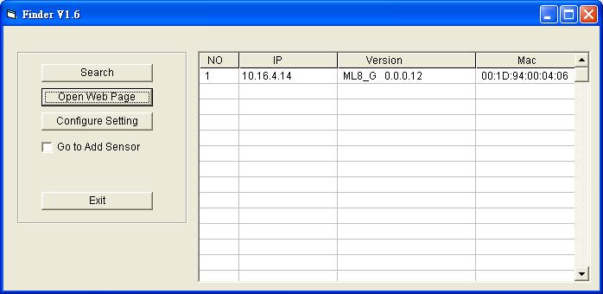
Step 11. Once the Control Panel is identified, select the panel and click on “Open Web Page” to link to the IP Security System Web page.
Step 12. Software installation for VST-2735/ VST-2752 IP Panel is now completed.

- CONFIGURE SETTING
The Configure setting is for you to setup the network setting manually.
Step 1. Click on Configure Setting, the following window will display:
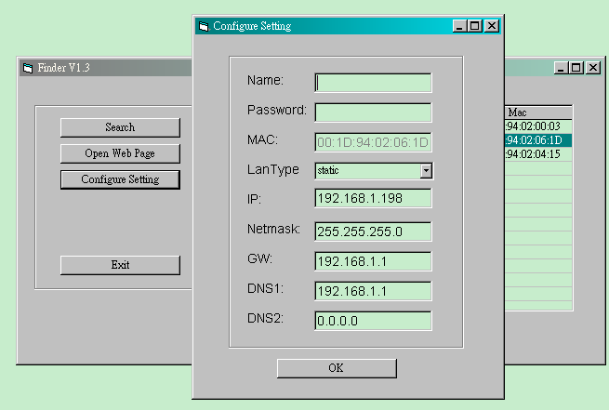
Step 2. Enter the network information and the Control Panel’s web user name and password.
(Default) User Name: admin
(Default) Password: admin1234
Step 3. Click on OK to confirm. When the username and password are correct, a window will display: Status: Configure success!!

4. Connecting to Webpage
Step 1. Select the Control Panel in the Finder software and click on “Open Webpage” to connect to panel webpage.
Alternatively, enter the Control Panel IP address displayed in Finder into your browser’s address section and click “GO”.
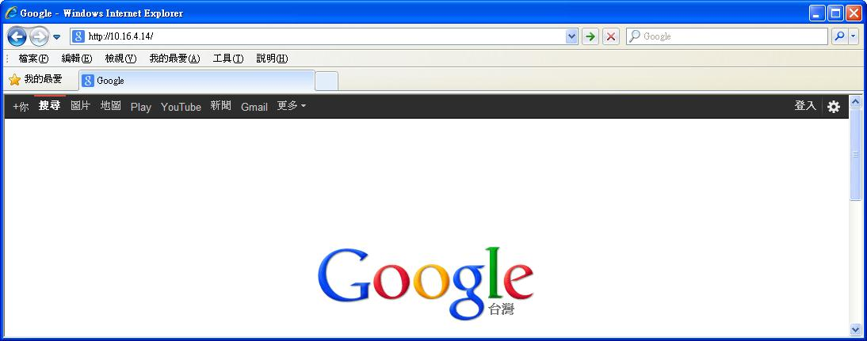
Step 2. Enter the User name & Password.
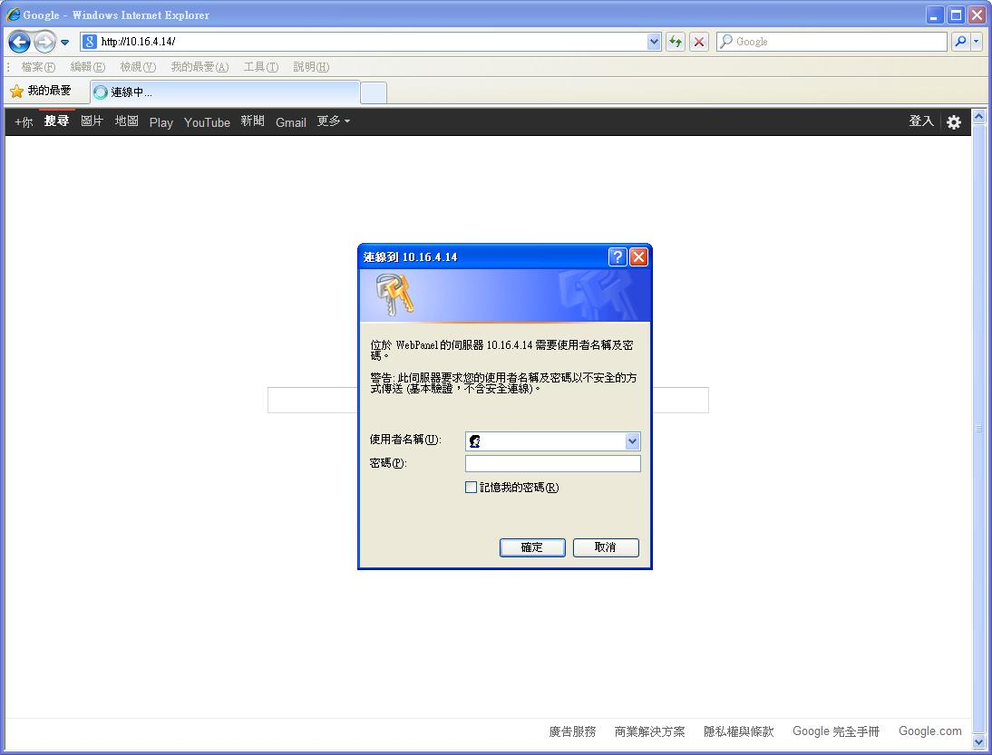
Step 3. Enter the User name & Password and then press “OK”.
User Name: admin Password: admin1234

Step 4. You will enter the Control Panel webpage, the current Control Panel information will be displayed.
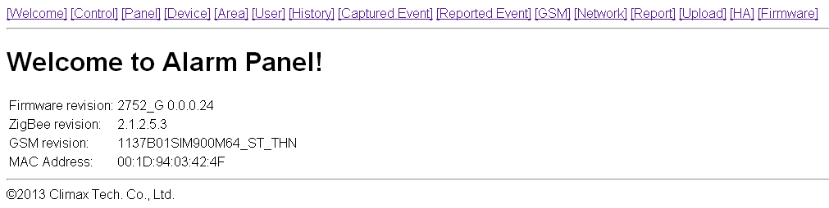

5. SYSTEM SETTINGS

5.1. User
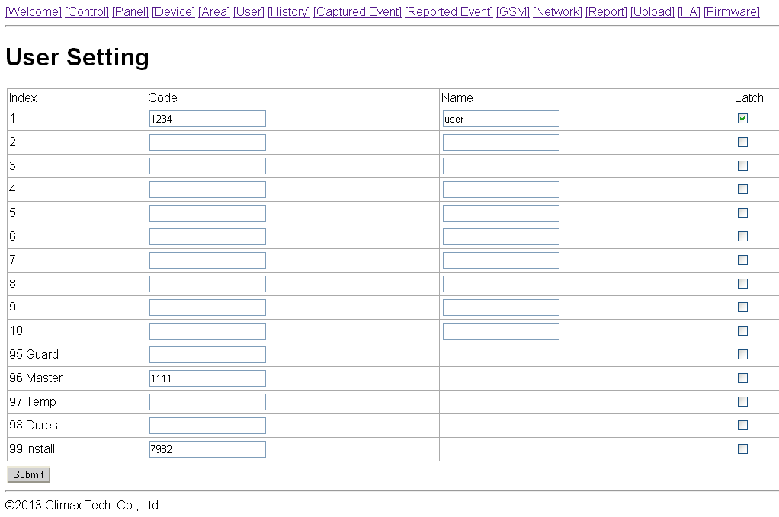
- User Code
The User Codes are used for users to acess the alarm system. A total of 10 4-digit User Codes can be stored in the Control Panel. Each individual User can be given a name for easy recognition when viewing system events.
User PIN code #1 is activated with “1234” as factory default. User PIN code #2~#10 are deactivated by factory default.
<Note>
    - When entering User PIN Codes with a Remote Keypad, if the wrong PIN Codes were entered 5 times in 10 minutes, the Control Panel will prohibit further User PIN Code entry for 15 minutes. All User PIN Codes entered during the 15 minute period will result in error for the Remote Keypad.
- Guard Code
The Guard Code is designed for security personnel to arm/disarm the system. When this code is used for accessing the system, the Control Panel will record the event separately from the User Codes.
The Guard Code consists of 4 digits and is not activated as default by the factory.
- Master Code
The Master Code is for the user to access the Programming Mode via LCD and keypad control.
Factory default: 1111.
- Temporary Code
The Temporary Code is used to access the system for a temporary user and is valid only once per arming and once per disarming. Afterwards, the Temporary Code is automatically erased and needs to be reset for a new Temporary user.
The Temporary Code consists of 4 digits and is not activated as default by the factory.
- Duress Code
The Duress Code is used to access the system in duress situation. When this code is used for accessing the system, the Control Panel will report a secret alarm message without sounding the siren to the Central Monitoring Station to indicate of a “Duress Situation in Progress”.
The Duress Code consists of 4 digits and is not activated by factory default.
- Installer Code
The Installer Code is used for the user to access the Installer Mode via LCD and keypad control. It also allows access to Control Panel via SMS remote command. (VST-2752 only)
Factory default: 7982.
- Latch Option
Whe the option is selected, the Control Panel will report all arming/disarming action by this user.
Latch.
When the the Latch option box is ticked, the Latch option is turned ON.
To edit the Codes on Web Page:
Step 1. Key in your preferred codes from 1 to 20 digits (at least 4 digit code is recommended)
Step 2. Enter a name for the code (optional)
Step 2. Choose to tick On / Off the Latch Option box.
Step 3. Press “Submit” to confirm the new uploaded details.

5.2. Report
This page is for you to enter the report destination setting. Control Panel can store up to 8 report destinations.
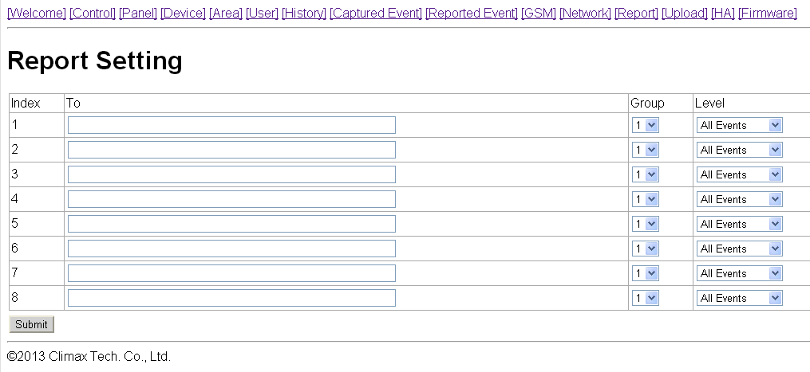
- Reporting Type:
Control Panel supports 5 reporting types:
- IP/GPRS reporting in CID format:
Reporting destination format: ip://Account@Server IP:Port/CID
For Example: ip://6543@59.124.123.22:8765/CID
ip:// | 6543 | @59.124.123.23 | :8765 | /CID
Reporting type | Account (4-8 digits) | Server IP address | Port number | Reporting Format
- IP/GPRS reporting in SIA format:
Reporting destination format: ip://Account@Server IP:Port/SIA
For Example: ip://6543@59.124.123.22:8765/SIA
ip:// | 6543 | @59.124.123.23 | :8765 | /SIA
Reporting type | Account (4-8 digits) | Server IP address | Port number | Reporting Format
- SMS reporting in CID format: (VST-2752 only)
Reporting destination format: sms://Account@mobile number/CID
For Example: sms://1234@0926064587/CID
sms:// | 1234 | @0926064587 | /CID
Reporting type | Account (4-8 digits) | Mobile Number | Reporting Format
- SMS reporting in Text format: (VST-2752 only)
Reporting destination format: sms://mobile number/TEXT
For Example: sms://0926064587/TEXT
sms:// | @0926064587 | /TEXT
Reporting type | Mobile Number | Reporting Format
- GSM Digital reporting in CID format: (VST-2752 only)
Reporting destination format: gsm:// Account@Tel number
For Example: gsm://1234@0926064587
gsm:// | 1234 | @27940001
Reporting type | Account (4-8 digits) | Telephone Number
- Email reporting
Reporting destination format: mailto: user@example.com
For Example: mailto: sales@climax.com.tw
mailto: | sales@climax.com.tw
Reporting type | Email Account
- Voice reporting (VST-2752 only)
Reporting destination format: voice:// Tel number
For Example: voice://1234567890
voice:// | 1234567890
Reporting type | Telephone Number
<Note>
    - Reporting type must be entered in lowercase letters.
    - The SMTP setting under Network page must be completed first for email reporting to function.
- Groups:
You can assign reporting destinations to different groups, the reporting groups function according to the following rules:
- The reporting priority is based on to group number sequence. From Group 1 → Group →Group 2 → Group 3 →….etc
- When more than one reporting destinations are assigned to a group, if a report is sent to one of the detinations successfully, the system will stop reporting to the rest of the reporting destination in the same group and move on to report to the next group.
If the Control Panel fails to send report to the first detination in a group, it will move on to the next reporting destination. If all reporting destinations in the group cannot be reached, the Control Panel will move on to the next group
If the Control Panel fails to report to all reporting groups, it will start reporting from group 1 and continue retrying until one report is made successfully.
- Level:
You can assign reporting destinations to report different events, options include:
- All Events: The Control Panel will report both alarm and system status events to this reporting destination.
- Status Events: The Control Panel will only report system status events to this reporting destination.
- Alarm Event: The Control Panel will only report alarm events to this reporting destination.
<Note>
    - Voice Reporting will only report alarm events. If set to status event, the Control Panel will not make any reports..

5.3. Panel
This page is for you to configure panel settings.
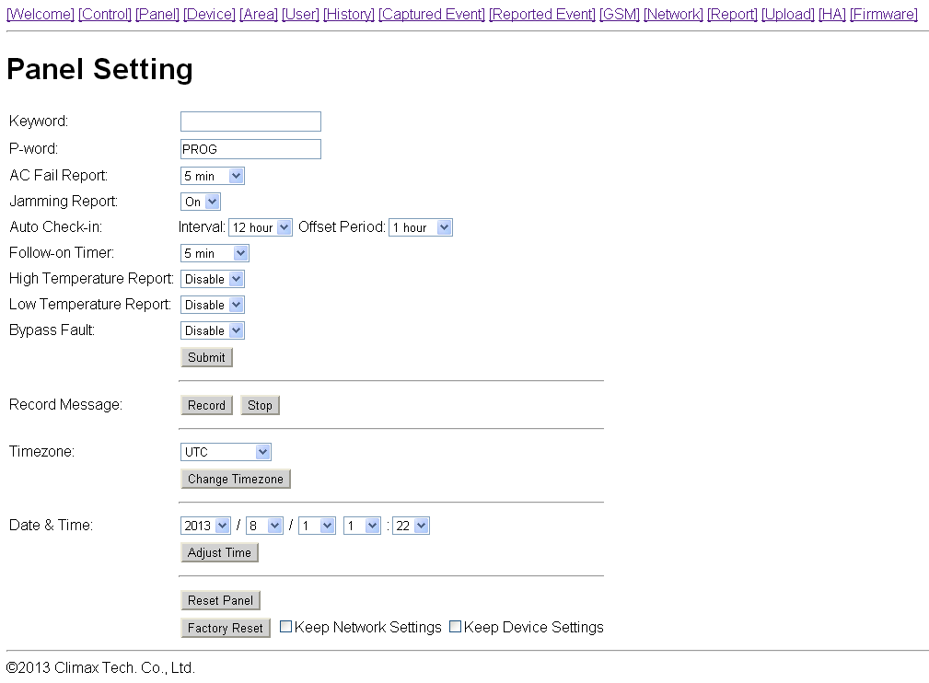
- Keyword (VST-2752 only)
The Keyword is used for receiving SMS commands from users. When a user sends a SMS command to the Control Panel, the correct keyword must be entered along with a valid User PIN code for the Control Panel to recognize the command. The Keyword is disabled by default.
- P-word (VST-2752 only)
The P-word is also used for receiving SMS commands from Installers. When an installer sends a SMS command to the Control Panel, the correct P-word must be entered along with Installer code for the Control Panel to recognize the command. The P-word is “PROG” by default.
- AC Fail Report
This is for you to set the waiting time for the Control Panel to make report after detecting AC failure. Factory default is set to 5 minutes.
- Jamming Report
This is for you to set whether the Control Panel should detect radio frequency interference and make report when interference is detected. Factory default is set to On. When radio jamming is detected, the Control Panel will report the event accordingly.

- Auto Check-in
This is for you to set the interval time the Control Panel waits before making a regular check-in report
- Interval: Set the interval waiting time
- Offset Period: This is to set the time delay before the first “Auto Check-in Report” report to be made. For example, if “Offset” time period is set to 2 Hours, then the Control Panel will make the first “Auto Check-in Report” report after 2 hours.
- Follow-On Timer (VST-2752 only)
After the Control Panel makes a GSM digital report to the Central Monitoring Station, the Central Monitoring Station can choose to enter a “Listen-in” period according to the Follow-On timer duration set here. During this period, the Central Monitoring Station will be able to listen to what is happening around the Control Panel through the microphone on the panel.
- High Temperature Report
This is for you to set the High Temperature reporting threshold. If the Control Panel has learnt in a Temperature Sensor, it will make High Temperature report and raise alarm when the temperature exceeds the threshold. When the temperature drops below set value again, the Control Panel will stop alarming and send High Temperature Restore report. Factory default is set to Disable.
- Low Temperature Report
This is for you to set the Low Temperature reporting threshold. If the Control Panel has learnt in a Temperature Sensor, it will make Low Temperature report and raise alarm when the temperature drops below the threshold. When the temperature rises above set value again, the Control Panel will stop alarming and send Low Temperature Restore report. Factory default is set to Disable.
- Bypass Fault:
This is for you to set whether you want to ignore fault events regarding Ethernet or GSM function. Bypassed fault events will not displayed under Control webpage or cause the fault LED will to light up and emit beeps. Please refer to 9. Panel Control for more information regarding system fault event management.
- IP: When IP is selected, Ethernet related faults will be ignored.
- GSM: When GSM is selected, GSM related faults will be ignored.
Factory default is set to Disable.
After finishing the above settings, press “Submit” to confirm the change.
- Record Message (VST-2752 only)
This is for you to record the Address Message for voice reporting. The Address Message is the voice message that is played at the beginning of every voice report to notify the call recipient of the caller’s information. The default message is “Alarm System.” You can also record your own 10-second Address Message with this function.
To record your own Address Message:
1. Click “Record”
2. The Control Panel will emit 1 beep. Speak clearly and slowly for the Control Panel to record your Address Message
3. When you finish recording, press “Stop” to end recording, or the recording will stop automatically when it reaches 10 seconds
- Time Zone
This is for you to set your Time Zone.
- Date & Time
This is for you to set your current date and time.
After finishing Time Zone and Date/Time setting, press “Adjust Time” to confirm the change.
- Reset
Press the “Reset” button to restart the Control Panel.
- Factory Reset
Press the “Factory Reset” button to clear all stored information and settings in the Control Panel, all settings will be returned to factory default. You can choose to tick the box for “Keep Network Setting” or “Keep Device Setting” before pressing Factory Reset to keep part of the settings unchanged.

5.4. Area
This page is for you to configure area settings.
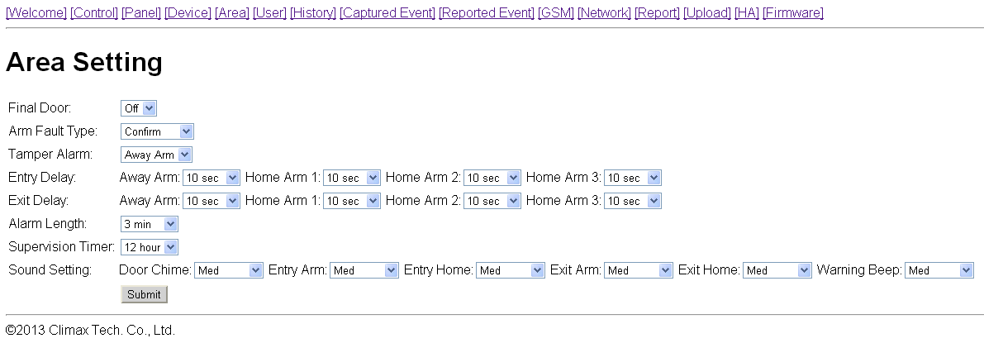
- Final Door
- Final Door On: When the system is Away Armed with a Door Contact set to Entry attribute, the system will automatically arm the system once the Door Contact is closed even if the entry delay timer has not expired yet.
- Final Door Off: When the system is Away Armed with a Door Contact set to Entry attribute, the system will only arm the system after the entry delay timer expires.
- Factory Default is set to Final Door Off.
- Arm Fault Type
- Confirm: When set to Confirm, If you attempt to arm when a fault exists within the system, the arming action will be prohibited, and a message will be displayed “Fault exists! Please Confirm!” You need to arm the system again to confirm your action and arm the system. (Factory Default)
- Direct Arm: When set to Direct Arm, If you attempt to arm when a fault exists within the system, the system will enter selected arm mode without further notification about fault events.
- Factory Default is set to Confirm.
- Tamper Alarm
- Away Arm: Tamper alarm will only be activated when tamper switch is triggered under Away Arm mode (Tamper event will still be reported normally in Home/Disarm mode).
- Always: Tamper alarm will be activated whenever tamper switch is triggered.
- Factory Default is set to Away Arm.
- Entry Delay
Set the Entry Delay Timer for Away Arm, Home Arm 1, Home Arm 2, and Home Arm 3 modes. When a device set to Entry attribute is triggered under arm mode, the Entry Delay Timer will begin to countdown. The system must be disarmed before the timer expires or an alarm will be activated.
Factory default is set to 10 seconds.

- Exit Delay
Set the Exit Delay Timer for Away Arm, Home Arm 1, Home Arm 2, and Home Arm 3 modes. When you arm the system, the system will enter your selected arm mode after the Exit Delay Timer expires
Factory default is set to 10 seconds.
- Alarm Length
When an alarm is activated, both the Control Panel siren and external siren will raise alarm according to the Alarm Length setting.
Factory default is set to 3 minutes.
- Supervision Timer
Set the supervision timer for accessory devices, if no supervision signal is received within set duration for a certain device, the Control Panel will report the situation accordingly.
Factory default is set to 12 hour.
- Sound Setting
- Door Chime: If not disabled, the Control Panel will sound a door chime sound when a Door Contact set to Entry attribute is activated in Disarm mode. .
- Entry Arm: If not disabled, the Control Panel will sound beeping sounds when a Door Contact set to Entry attribute is activated in Away Arm mode. .
- Entry Home: If not disabled, the Control Panel will sound beeping sounds when a Door Contact set to Entry attribute is activated in Home Arm mode. .
- Exit Arm: If not disabled, the Control Panel will sound beeping sounds when during Exit Delay Timer for Away Arm mode.
- Exit Home: If not disabled, the Control Panel will sound beeping sounds when during Exit Delay Timer for Home Arm mode.
- Warning Beep: If not disabled, the Control Panel will sound beeping sounds every 30 seconds when fault exists within system.

5.5. Network
This page is for you to configure network settings.
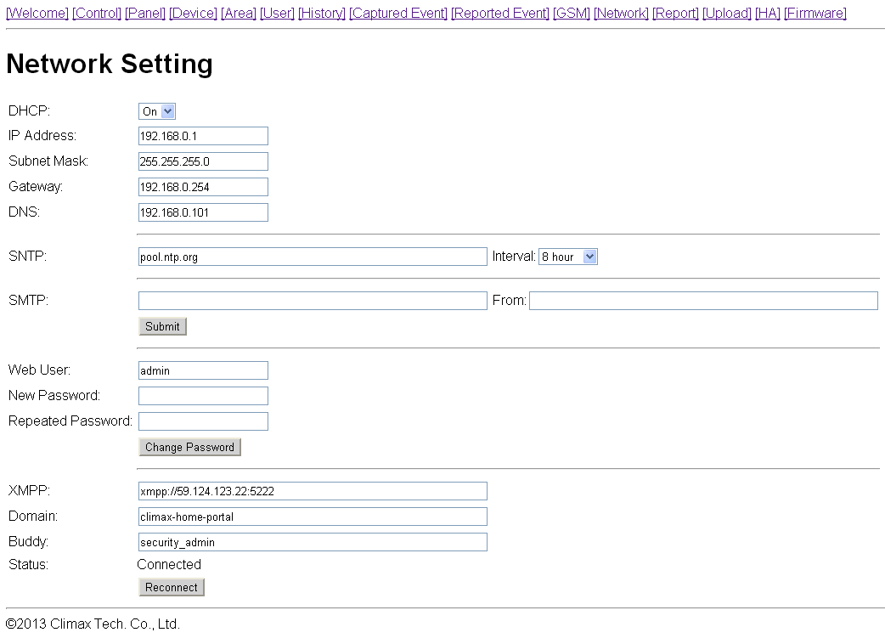
- DHCP
- On: If DHCP is set to On, the Network will obtain the IP address automatically with a valid Network DHCP Server. Therefore, you won’t need to do any settings. You can only set DHCP to On if your Network environment supports DHCP. It will automatically generate all information.
- Off: If DHCP is set to Off, you neet to enter the Network information manually for IP Address, Subnet mask, Default gateway, Default DNS. Please make sure that you have obtained all required values according to your Network environment. Please contact your local service provider for more information.
- SNTP
SNTP setting is for you to enter an internet time server to synchronize and update Control Panel time automatically according to set interval times
- SMTP
SMTP setting is for you to program the mail server related settings. The email account you set here would be used to send email reports or email the triggered images/videos from PIR Camera/Video Camera. For email report or upload destination, please refer to Report or Upload section.
SMTP format: smtp://user:password@example.com ／From：name@example.com

<NOTE>
- SMTP setting must be entered in all lowercase letters
- The Control Panel does not support SMTP encryption method such as SSL or TLS.
- Administrator Account Setting
Here you can program the user name and password used for accessing the webpage.
- Web User: This is the user name you entered when you access the panel webpage. Default web user is “admin”. If you want to change the user name, enter a new name in the field. Maximum character allowed is 20.
- New Password: If you want to change the password, enter the password in this field. Maximum character allowed is 20.
- Repeat Password: Repeat the password again in this field
After finishing above settings, click “Submit” to update settings.
- XMPP
XMPP setting enables the Control Panel to query the set destination. This setting is required for the Control Panel to connect to Climax’s Home Portal Server for further remote control.
- XMPP: server address. ex: xmpp://user:password@example.com
- Domain: domain address
- Buddy List: contact destination
<NOTE>
- XMPP setting must be entered in all lowercase letters

5.6. GSM
This page is for you to check your GSM status configure GPRS network settings. (VST-2752 only)
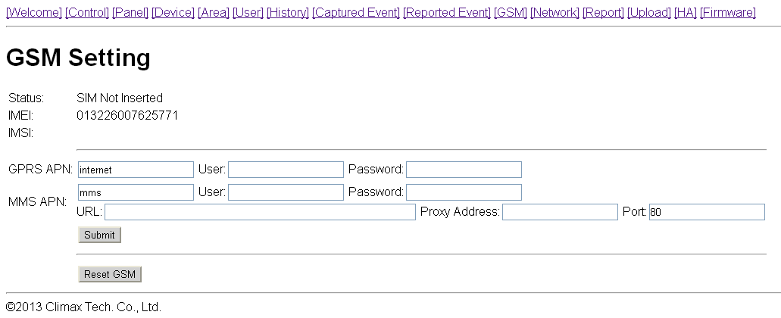
- Status
Your GSM module status will be displayed here.
- IMEI
The IMEI code of your GSM module will be displayed here.
- GPRS
In order to allow GPRS to serve as a back-up IP Reporting method, this section will need to be programmed before reporting.
- APN (Access Point) Name
It is the name of an access point for GPRS. Please inquire your service provider for an APN. When APN is set, the system becomes valid for internet connection.
- User (GPRS)
It is the Log-in name to input before accessing the GPRS feature. Please inquire your service provider for information.
- Password (GPRS)
It is the User Password to input before accessing the GPRS feature. Please inquire your service provider for information.
- MMS
MMS setting is required if you want to send pictures/videos captured by PIR Camera or PIR Video Camera to mobile phones. Please refer to Upload for setting detail.
- APN (Access Point) Name
Enter a MMS APN name provided by your service provider.
- User
Enter the Log-in name for accessing the MMS feature provided by your telecom service provider.

- Password
Enter the password for accessing the MMS feature provided by your telecom service provider.
- URL
Enter the MMS APN URL provided by your telecom service provider.
- Proxy Address
Enter the MMS Proxy Address provided by your telecom service provider.
- Proxy Port
Enter the MMS Proxy Port provided by your telecom service provider.
After finish entering all information, click “Submit”, the GPRS and MMS settings will be updated accordingly.

- Reset GSM
This is for you to reset the GSM module.

5.7. Upload
This page is for you to set upload destination for captured pictures and videos from PIR Camera and PIR Video Camera.
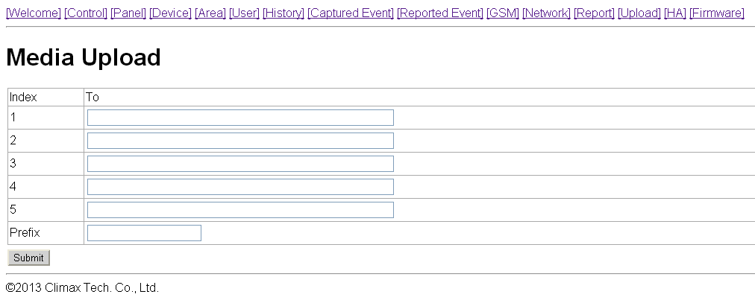
- 1~5
Enter an email address, FTP address, or mobile number for MMS delivery
For email delivery, the SMTP setting under Network must be completed. The format is: mailto: user@example.com
For FTP, the format is: ftp://user.password@example.com:port/path
For server, the format is: http://ip:port/path
For MMS delivery to mobile phone (VST-2752 only), the MMS setting under GSM must be completed. The format is: mms: 0987654321
- Prefix
Specify a prefix to be titled for every captured picture/video file.

6. Device Management
This page for you to learn in, edit, delete and control all the accessory devices. A total of 40 devices are allowed to be learnt in to the system, including RF and ZigBee devices. Only 6 PIR Cameras (VST-852/VST-852 Pro) or Video Camera (VST-873/VST-873Pro) can be learnt into the system.
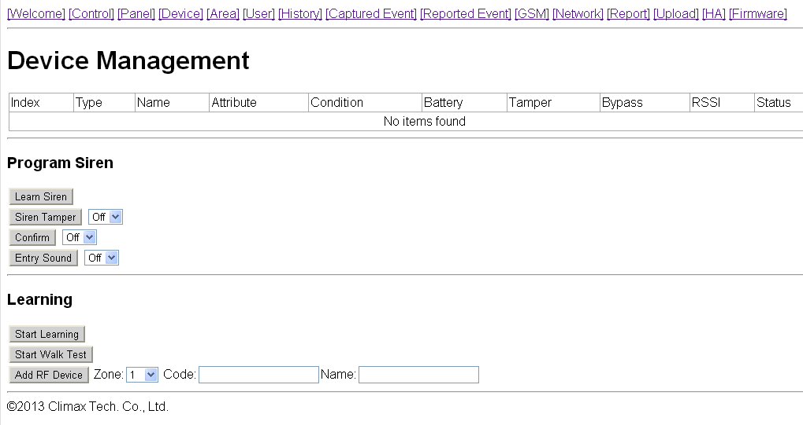

6.1. Learning
Step1. Under Disarm Mode, press “Start Learning”. The Control Panel will enter learning webpage. The Control Panel LED 1 will flash green.
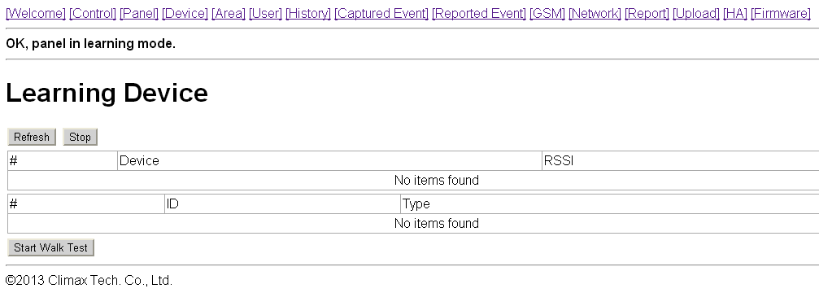
Step2. Press the learn button on your device, for ZigBee device, press and hold the learn button for about 10 seconds (please refer to device manual for detail) to transmit a learn code.
Step3. If the Control Panel receives the learn code it will emit 2 short beeps, click the “Refresh” button to display the device information on webpage. If the Control Panel emit 1 long beep instead, it means the device has already been learned into the Control Panel.
<Note>
    - If the Control emits 2 short beep when learning in ZigBee sensors, but does not display device information when you refresh the page, it means the Control Panel received supervision code from the sensor instead of learn code. Please resend the learn code again.
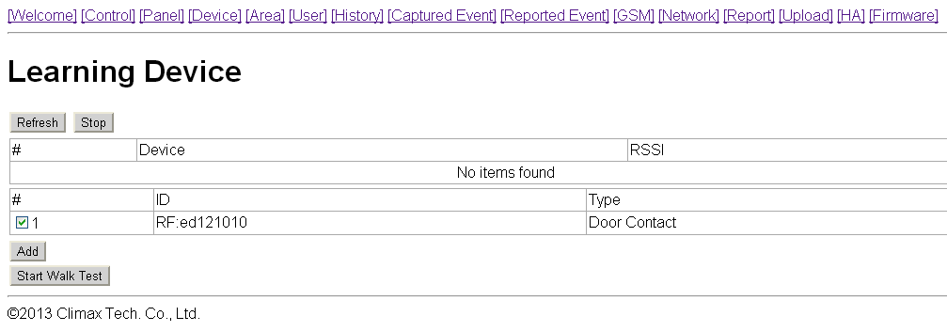
Step4. Tick the device # box, then click “Add” to include the device in the Control Panel.
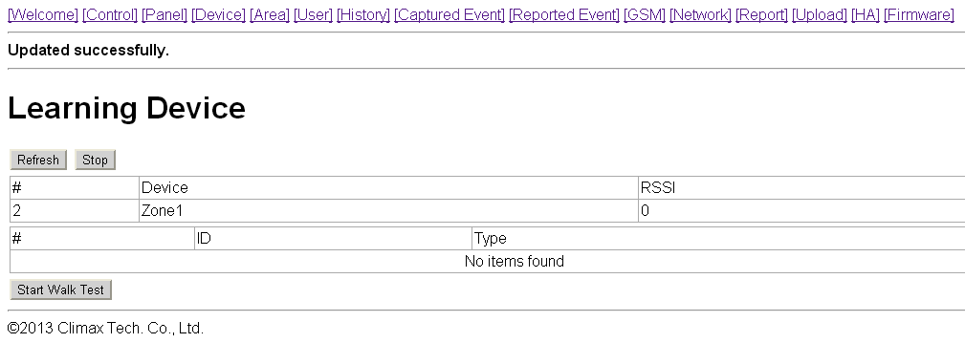
Step5. The Control Panel will display “Updated Successfully” message and the new learned in device zone accordingly. The device is now learn in to the system.
Step6. You can click “Stop” button to leave learning mode, the Control Panel will return to normal mode.
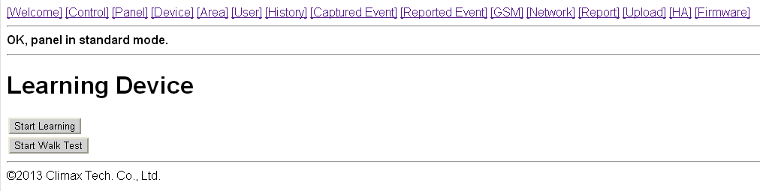

Step7. After learning a device into the Control Panel, the Device Webpage will be changed to list all available functions.
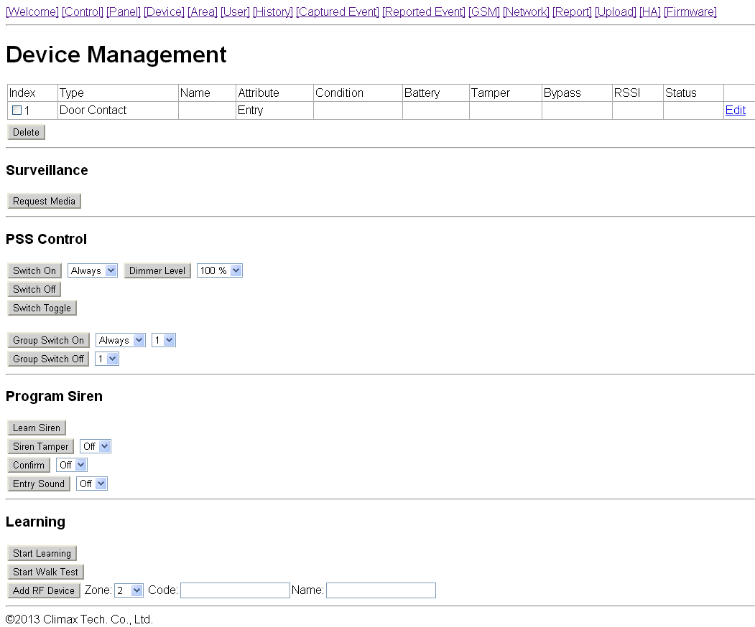

6.2. Add Device
For RF devices, you can also add device into the Control Panel by entering the device’s RF code. (This function cannot be used with ZigBee devices)
Step1. Select the zone number you want to assign the new device to
Step2. Enter the device’s RF code
Step3. Enter device name.
Step4. Click “Add RF Device ” to include the device in the system.

6.3. Walk Test
Step1. Press “Start Walk Test” under either Learning or Device Management webpage. The Control Panel will enter Walk Test page.
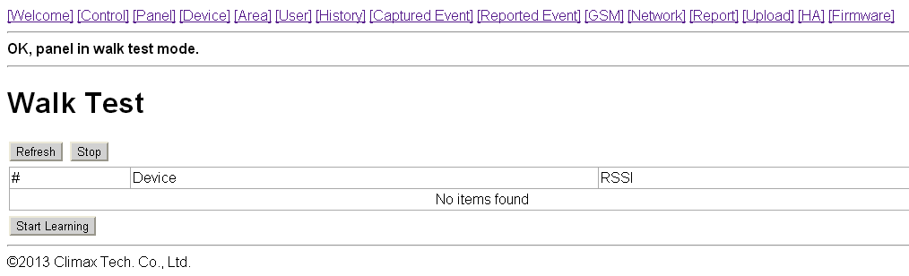
Step2. Press the learn button on your device (please refer to device manual for detail) to transmit a test code.
Step3. If the Control Panel receives the test code, it will emit a long beep, click the “Refresh” button to displayed accordingly on the webpage.
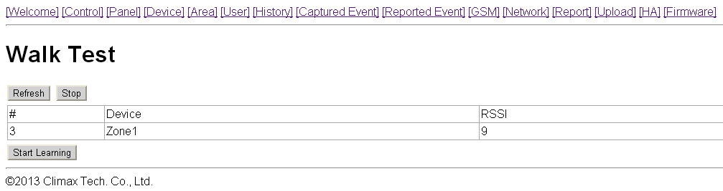
Step4. You can click “Stop” button to terminate walk test, the Control Panel will return to normal mode.
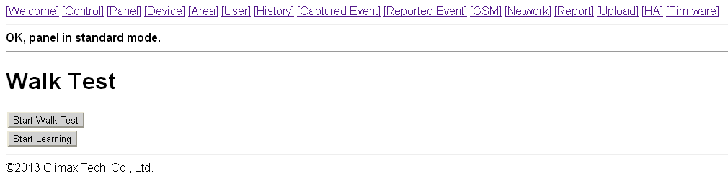

6.4. Edit Device
After you learn in a device to the system, you should proceed to edit its setting.
Step1. Under Device Management webpage, click “Edit”. The Control Panel will enter device editing page.
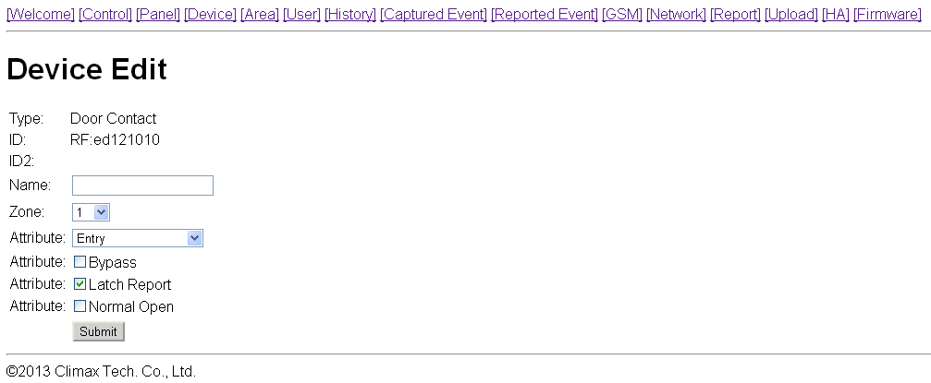
Step2. Proceed to edit device settings, click “Submit” when you are satisfied with all settings or information..
- Name: Enter a name for the device, A maximum of 20 characters are allowed
- Zone: Select the device zone number.
- Attribute:
For Door Contact you are requested to select the device attribute from Burglar, Home Omit, Home 1/2 Omit, Home 1/3 Omit, Home Access, Delay Zone, Away Only, Entry, Away Entry, 24 Hr, Fire, Medical Emergency, Water, Set/Unset Silent Panic, Personal Attack.
For PIR Sensor, you are requested to select the device attribute from Burglar, Home Omit, Home 1/2 Omit, Home 1/3 Omit, Home Access, Delay Zone or Entry Zone.
For Remote Controller, you are requested to select the device attribute from Silent Panick or Personal Attack.
Attribute List:
- Burglar
- When the system is in any Arm mode, if a “Burglar” device is triggered, a “Burglar Alarm” will be activated immediately and reported.
- Home Omit
- When the system is in Home Arm 1/2/3 mode, if a “Home Omit” device is triggered, the Control Panel will not raise alarm. It will still send a report for this event
- When the system is in Full Arm mode, if a “Home Omit” device is triggered, the Control Panel will respond in the same way as if a “Burglar” device is triggered.
- Home 1/2 Omit
- When the system is in Home Arm 1/2 mode, if a “Home 1/2 Omit” device is triggered, the Control Panel will not respond. It will still send a report for this event
- When the system is in Away Arm or Home Arm 3 mode, if a “Home 1/2 Omit” device is triggered, the Control Panel will respond in the same way as if a “Burglar” device is triggered.
- Home 1/3 Omit
- When the system is in Home Arm 1/3 mode, if a “Home 1/3 Omit” device is triggered, the Control Panel will not respond. It will still send a report for this event
- When the system is in Away Arm or Home Arm 2 mode, if a “Home 1/2 Omit” device is triggered, the Control Panel will respond in the same way as if a “Burglar” device is triggered.
- Home Access
- When the system is in Home mode, if a “Home Access” device is triggered, the Control Panel will start an Entry Delay period to give enough time to disarm the system. It will also send a report for this event
- When the system is in Full Arm mode, if a “Home Access” device is triggered, the Control Panel will start a Burglar Alarm and a burglar message will be reported.
- Delay Zone
- When the system is in any Arm mode, if a “Delay Zone” device is triggered, a “Burglar Alarm” will be activated immediately and reported.
- When the system is in any Armed mode, and the Control Panel is counting down the Entry Delay, if a “Burglar” device is triggered, the Control Panel will not respond.
- During the Exit Delay period, if a “Burglar” device is triggered, the Control Panel will not respond .
- Away Only
- When the system is in Away Arm mode, if an “Away Only” device is triggered, a “Burglar Alarm” will be activated immediately and reported.
- When the system is in any Home Arm mode, if an “Away Only” device is triggered, the Control Panel will not respond.
- During the Entry Delay or Exit Delay period, if an “Away Only” device is triggered, the Control Panel will not respond .
- Entry
- When the system is in any Arm mode, if an “Entry” device is triggered, the Control Panel will start an Entry Delay countdown timer for the user to disarm the system.
- After the delay period has expired and no correct PIN code has been entered, the Control Panel will activate a “Burglar Alarm” and the event will be reported.
- When the system is in Disarm mode, if a “Entry” is triggered, the Control Panel will make a “ding-dong” Door Chime sound (if Door Chime function is not disabled).
- Away Entry
- When the system is in Away Arm, if an “Away Entry” device is triggered, the Control Panel will start an Entry Delay countdown timer for the user to disarm the system.
- After the delay period has expired and no correct PIN code has been entered, the Control Panel will activate a “Burglar Alarm” and the event will be reported.
- When the system is in Disarm mode, if a “Entry” is triggered, the Control Panel will make a “ding-dong” Door Chime sound (if Door Chime function is not disabled).
- When the system is in any Home Arm mode, if an “Away Entry” device is triggered, the Control Panel will not respond.
- During the Entry Delay or Exit Delay period, if an Away Entry device is triggered, the Control Panel will not respond
- 24 Hour
- The 24 Hour device is active all the time and does not have to be armed or disarmed. An Event Code of #130 will be reported with trigger.
- Fire
- The Fire device is active all the time and does not have to be armed or disarmed. An Event Code of #111 will be reported with trigger.
- Medical Emergency
- A Medical Emergency device is active all the time and does not have to be armed or disarmed. An Event Code of #101 will be reported with trigger.
- Water
- The Water device is active all the time and does not have to be armed or disarmed. An Event Code of #154 will be reported with trigger.
- Set/Unset (For Door Contact Only)
- If the Door Contact is set to Set/Unset, the system will be disarmed when the Door Contract is triggered, and armed when Door Contact is closed.
<Note>
    - Please refer to Normal Open/Normal Close section below for further detail.
- Silent Panic
- If the device attribute is set as Silent Panic, when the device is activated, the Control Panel will report a Slient Panic alarm without sounding an audible siren. An event code of 122 will be reported.
- Personal Attack
- If the device attribute is set as Personal Attack, when the device is activated, the Control Panel will activate an alarm and report an event code of 120 will be reported.
- Bypass: If Bypass is selected, the device will be deactivated. When a bypassed device is triggered, the Control Panel will not raise alarm.
- Latch Report: If Latch Report is selected, the Control Panel will send report when the device is triggered.
- Normal Open: This option is only available for Door Contact:
If Normal Open is selected, the Door Contact will be triggered when it is closed.
If Normal Open is selected, the Door Contact will be triggered when it is opened.
- Group: This option is only available for Power Switch. You can assign multiple Power Switches to a group and control the group together
<Note>
    - To avoid accidental tamper trigger, when you are changing device batteries or moving device locations, be sure to use the Bypass function to temporarily deactivate the device.

6.5. Delete Device
In order to remove devices from the Control Panel, check the number boxes before the device name, then click Delete, the selected devices will be removed.

6.6. Request Media
You can manually control the selected PIR Camera and PIR Video Camera to take a picture or record a 10-second video clip. The requested picture and video clip can be viewed in “Captured Event” webpage.

6.7. Power Switch Control
This section is for you to control Power Switch in the system
- Switch On: Select the desired Power Switch, then choose the time length you want to turn on the Power Switch, then click “Switch On” to confirm.
- Switch Off: Select the desired Power Switch, then click “Switch Off” to turn off.
- Switch Toggle: Select the desired Power Switch, the click “Switch Toggle.” If the Power Switch is on, it will be turned off; if the Power Switch is off, it will be turned on instead.
- Dimmer Control (%): This function is for Power Switch with Dimmer function only. Select the desired Power Switch with Dimmer, then choose the power level percentage you want to adjust. Click “Switch Level %” to confirm the change.
- Group Switch On: You can control Power Switches assgined to one group together. Select the desired Power Switch group, then choose the time length you want to turn on the Power Switches, then click “Group Switch On” to confirm.
- Group Switch Off: Select the desired Power Switch group, then click “Group Switch Off” to turn off.

6.8. Siren Learning/Control
This section is for you to learn in Indoor Siren or Outdoor Bell Box, and edit their settings.
- Learn Siren: To learn in siren:
1. Put the siren into learning mode (Please refer to siren manual for detail)
2. Click “Learn Siren” to transmit a learn code.
3. Refer to siren manual to complete the learn in process.
- Siren Tamper: This is for you to enable/disable the siren tamper protection.
Select On/Off, then click “Siren Tamper” to confirm setting.
- Confirm: This is for you to set whether the siren should emit beeping sound when the system is armed or disarmed.
Select On/Off, then click “Confirm” to confirm setting.
- Entry Sound: This is for you to set whether the siren should beep warning sound during Entry Delay coundown timer.
Select On/Off, then click “Confirm” to confirm setting.
<Note>
    - When you are changing Siren batteries or moving Siren mounting location, you need to first deactivate the siren by selecting Bypass is siren edit screen, then turn off the Siren Tamper to avoid accidental tamper trigger.

7. Captured Events
Pictures/Videos captured by PIR Camera and PIR Video Cameras will be displayed in this page. Only the pictures/videos of the 6 latest events will be stored.
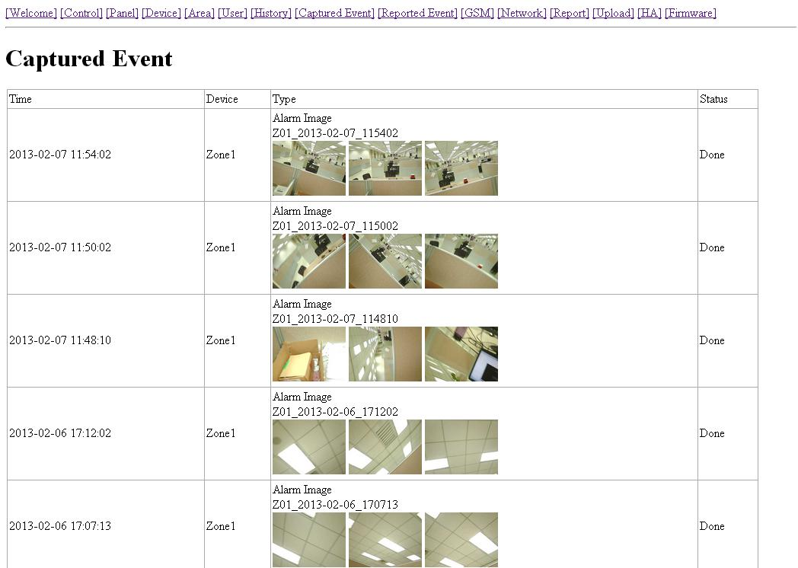
Click on the image or video to view the file.
- Time: The time when the picture/video is captured.
- Device: The Zone number of the PIR Camera/Video Camera triggered.
- Type: The type of the image/video.
- Alarm Image: When triggered under Away Arm/Home Arm mode, the PIR Camera will take three pictures.
- Requested Image: You can manually request the PIR Camera to take one picture.
- Alarm Video: When triggered under Away Arm/Home Arm mode, the PIR Video Camera will record a 10-second video clip.
- Requested Video: You can manually request the PIR Video Camera to take a 10-second clip.
- Status: The staus of the captured event are listed as follows:
- Waiting for Media Ready: The PIR Camera/Video Camera has captured image/video and will send the image video to Control Panel after the file is ready. For Alarm Image/Video, if you disarm the Control Panel under this status, the captured image/video will be deleted and no image/picture will be sent.
- Waiting for Capture: The PIR Camera/Video Camera is sending captured picture/video the the Control Panel. For Alarm Image/Video, if you disarm the Control Panel under this status, the captured image/video will be deleted and no image/picture will be sent.
- Upload: The PIR Camera/Video Camera has finished sending image/picture to Control Panel. The Control Panel is now uploading the image/video to programmed destination.
- Done: The Control Panel has finished uploading image/video successfully
- Fail: The PIR Camera/Video Camera was unable to send captured image/picture to Control Panel. Please check if the PIR Camera/Video Camera is out of order or under Low Battery, then perform Walk Test to check signal strength.
- Timeout: The PIR Camera/Video Camera did not respond to Control Panel. Please check if the PIR Camera/Video Camera is out of order or under Low Battery, then perform Walk Test to check signal strength.
<Note>
    - If a PIR Camera/Video Camera is triggered when the system is armed. Do not disarm the alarm system before the status displays “Upload” or “Done.” Otherwise the image/video will be deleted and will not be sent to Control Panel.

8. History Records

8.1. History
The Control Panel history events are recorded in this page.
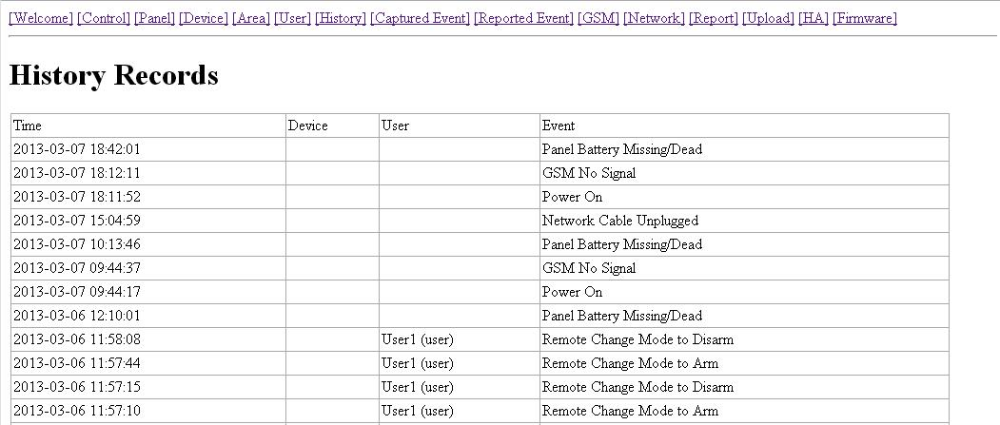
- The History memorizes the last 50 Panel events including:
  - All Alarm Events with Device Zone-
  - All Fault Warning Events from Panel or Device
  - All Arming And Disarming Events by Panel and Remote Controller
  - All Arming and Disarming Events by Remote Keypad with User information.
- Time: The time when the event take place
- Device : The device that triggered the event
- User: The user who perform the event action
- Event: The event content

8.2. Reported Event
The reported event history are recorded in this page..
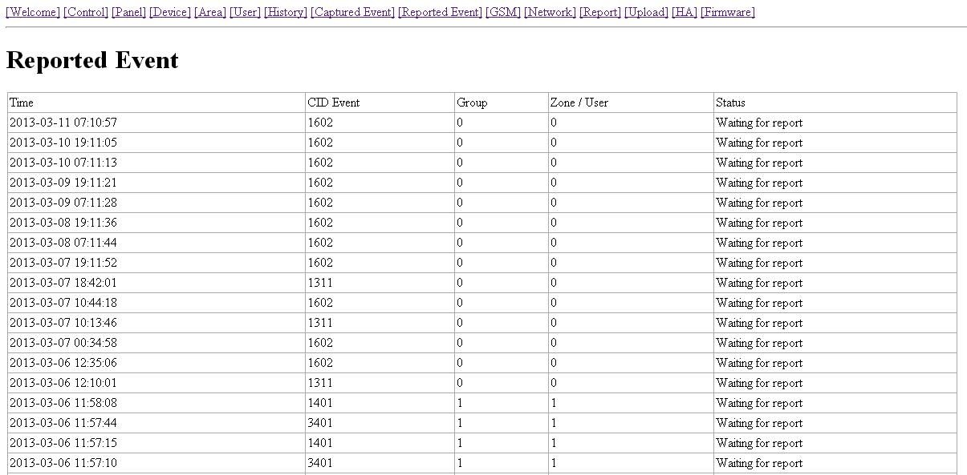
A total of 50 reported events can be recorded with Time, CID Event Code, Device Group/Zone and User information.
- Time: The time when the Control Panel begins the report
- CID Event Code Format:
The CID event code is recorded in 4 digits format of “Prefix + Event Code”
  - Prefix: “1” represents events taking place. “3” represents event restore.
  - Event Code: 3-digit CID event code.
For Example: “1302” means “Low Battery”, and “3302” means “Low Battery Restore.”
- Group: The group the device belongs to
- Zone/User:
For arming/disarming, the User PIN # will be displayed.
For device triggering, the device zone will be displayed.

9. Panel Control
Under this page, you can choose to Away Arm, Home Arm 1/2/3, or Disarm the system. If any fault exists within the system, they will be displayed under this page.
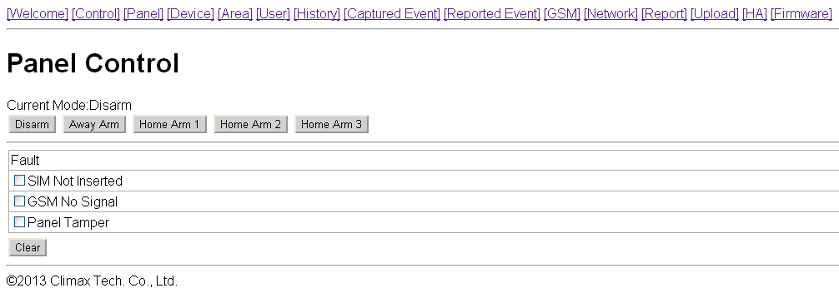
- Current Mode
Control Panel current mode.
- Away Arm:
Away Arm will arm all devices in the system.
- Home Arm 1/2/3:
You can choose to arm the system in 3 different Home Arm mode.
  - Under Home Arm 1, device set to Home Omit, Home 1/2 Omit or Home 1/3 Omit will not raise an alarm when triggered.
  - Under Home Arm 2, device set to Home Omit or Home 1/2 Omit will not raise an alarm when triggered.
  - Under Home Arm 3, device set to Home Omit or Home 1/3 Omit will not raise an alarm when triggered.
- Fault Events
Fault events in system are listed in the Fault section. If you try to arm the system when fault event exists a warning message “Fault Exists! Please Confirm!” will be displayed to notify you. You will need to arm the system again to force arm the system. Alternatively, you can select the fault events and click “Clear” to ignore the fault events. Cleared fault event will no longer prevent you from arming the system.
If all fault events are cleared, the fault LED will no longer light up or flash.

10. Home Automation
This page is for you to setup Home Automation rules with condition and execution setting to control the alarm system or home appliance automatically. A total of 20 Home Automation rules are available for setting.
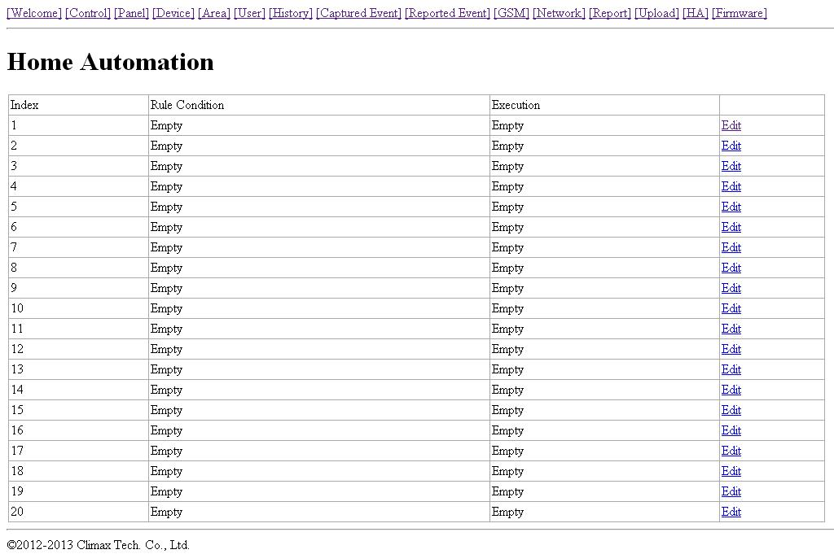
Step1. Click “Edit” to configure setting for the selected rule number. You will enter edit page.
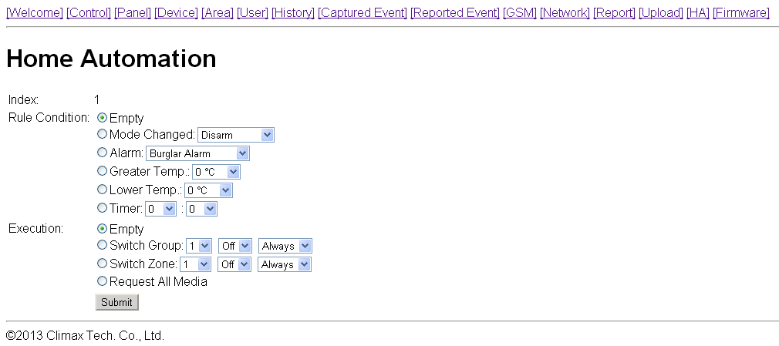
Step2. Set the Rule Condition.
- Mode Changed: The rule will be activated when the system mode is change to set mode.
- Alarm: The rule will be activated when the set alarm event is triggered.
- Greater Temp: The rule will be activated when the temperature rises above set value.
- Lower Temp: The rule will be activated when the temperature drops below set value.
- Timer: The rule will be activated when system reaches set time
Step3. Set the Execution Rule
- Switch Group: All Power Switches in selected group will be turned On/Off for set duration according to your setting.
- Switch Zone: All Power Switches in selected zone will be turned On/Off for set duration according to your setting.
- Request All Media: All PIR Camera/Video Camera in the alarm system will be requested to take a picture or record a 10-second video clip.
Step4. Click “Submit” to confirm the rule change.

11. Firmware
This page is for you update your Control Panel firmware.
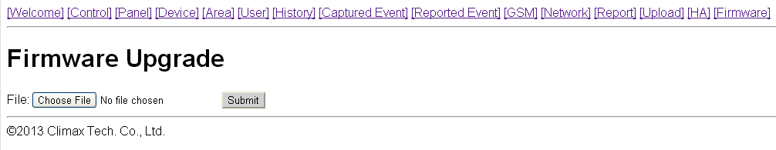
Step1. Select the firmware file in your computer
Step2. Click “Submit” to upload the firmware file to Control Panel.
Step3. It takes several minutes to complete update, do NOT power off during the process.
Step4. Once updating is complete, the Control Panel will reboot automatically.

12. Event Code
The events are reported with a qualifier before the event code. The qualifier “1” means the event has taken place, “3” means the event has been restored. For example, if the Control Panel reports “1302”, it means the panel is under low battery; if the Control Panel reports “3302”. It means the panel low battery condition has been restored.
- 100 – Medical
- 101 – Personal emergency
    - When the Wrist Transmitter / Emergency Pendant (WTR) is pressed.
- 102 – Inactive
- 110 – Fire
- 111 – Smoke
    - When the Smoke Detector (SD) is triggered.
- 114 – Heat
    - When the Heat Detector (HD) is triggered.
- 120 – Panic
    - When the Panic Button of the Remote Controller (RC) is pressed.
- 121 – Duress
    - When the Duress Code is entered to disarm or arm the system.
- 122 – Silent Panic
    - When the panic button on a Remote Controller (RC) set to silent panic is pressed.
- 130 – Burglar
    - When any one of the following devices is triggered:
      - The Door Contact (DC) set at Burglar (@ B)
      - The Door Contact (DC) set at 24 Hours (@ H)
      - The Door Contact (DC) set at Delay (@ D)
      - The PIR set at Burglar (@ B)
      - The PIR set at Delay (@ D)
- 131 – Burglar Perimeter
    - When a device set as Entry is triggered in away arm mode.
- 132 – Burglar Interior
    - When a device set at Entry is triggered in home arm mode.
- 137 – Panel Tamper
    - When the Control Panel tamper switch is triggered.
- 147 – Sensor Supervision Failure
    - When the Control Panel fails to receive the signal transmitted from any one of the devices individually for a preset period.
- 151 – Gas
- 154 – Water leakage
    - When a Water Sensor or Door Contact set as Water is triggered.
- 158 – High Temperature
    - When the temperature exceeds High Temperature setting.
- 159 – Low Temperature
    - When the temperature drops below Low Temperature setting.
- 162 – CO detector
- 301 – AC Failure
    - When the AC power fails for more than 10 sec.
- 302 – Low Battery
    - When the battery voltage of the Panel and any one of the devices is low.
- 311 – Panel Battery Missing/Dead
    - When the Control Panel Battery is missing or disconnected.
- 344 – Interference
- 374 – Arm with Fault
    - When fault exists in system, and the system is armed by confirming the arm action. (Arm Fault Type set to Confirm.)
- 383 – Device Tamper
    - When a device’s tamper switch is triggered.
- 384 – Device Low Battery
    - When a device’s is under low battery.
- 389 – Self Test Failure
- 400 – Arm/Disarm (by Remote Controller)
    - When the system is armed or disarmed by using the Remote Controller.
- 401 – Arm/Disarm by Panel
    - When the system is armed or disarmed by entering the PIN code.
- 408 – Set/Unset Disarm
- 407 – Disarm/Away Arm/Home Arm by Remote Keypad
- 456 – Home Arm
- 465 – Alarm Reset
- 570 – Zone Bypass
    - When fault exists in system, and the system is armed by ignoring the fault event. (Arm Fault Type set to Direct Arm)
- 602 – Periodic test report
    - When the Control Panel makes periodic Check-in reporting.
- 606 - Follow-On Function
    - When Control Panel reports to CMS to request opening Listen-in function. (VST-2752 only)

